**Activity: Find files with Linux commands**

experimentLabschedule1 houruniversal_currency_altNo costshow_chartIntroductory

infoThis lab may incorporate AI tools to support your learning.

**Activity overview**

Previously, you learned about Linux and how to communicate with the OS through the shell. You also learned how to use some of the core commands to navigate the Linux file system and read content from files it contains.

These are essential skills. For example, when investigating unauthorized access, you might navigate to and then read a user access report.

In this lab activity, you’ll navigate a Linux file structure, locate files, and read the contents of files. You’ll also need to answer a few multiple-choice questions based on the information contained in these files.

As a security analyst, it’s key that you know how to navigate, manage, and analyze files remotely via a Linux shell without a graphical user interface.

**Scenario**

In this scenario, you have to locate and analyze the information of certain files located in the /home/analyst directory.

Here’s how you’ll do this: **First**, you’ll get the information of the current working directory you’re in and display the contents of the directory. **Second**, you’ll navigate to the reports directory and list the subdirectories it contains. **Third**, you’ll navigate to the users subdirectory and display the contents of the Q1_added_users.txt file. **Finally**, you’ll navigate to the logs directory and display the first 10 lines of a file it contains.

To complete these tasks, you'll need to use commands that you've previously learned in this course. Well, it's time to practice what you’ve learned. Let’s do this!

***Note:****The lab starts with your user account, called analyst, already logged in to the Bash shell. This means you can start with the tasks as soon as you click the****Start Lab****button.***Disclaimer:** For optimal performance and compatibility, it is recommended to use either **Google Chrome** or **Mozilla Firefox** browsers while accessing the labs.

**Start your lab**

You'll need to start the lab before you can access the materials. To do this, click the green “Start Lab” button at the top of the screen.

Lab Start button displayed.

After you click the **Start Lab** button, you will see a shell, where you will be performing further steps in the lab. You should have a shell like this:

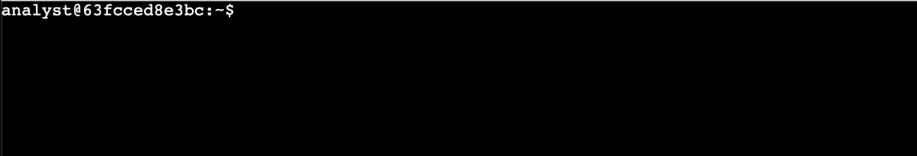

When you have completed all the tasks, refer to the End your Lab section that follows the tasks for information on how to end your lab.

**Task 1. Get the current directory information**

In this task, you must use the commands you learned about to check the current working directory and list its contents.

1. Display your working directory.
2. Display the names of the files and directories in the current working directory.

Which directory is your current working directory?

/var/logs

/home/analyst

/home/analyst/logs

/home

Submit

How many directories does the current working directory contain?

Five

Four

Two

One

Submit

Click **Check my progress** to verify that you have completed this task correctly.

Get the current directory information

Check my progress

***Note:****There is no penalty for clicking****Check my progress****and you’ll be shown a hint.*

**Task 2. Change directory and list the subdirectories**

In this task, you must navigate to a new directory and determine the subdirectories it contains.

1. Navigate to the /home/analyst/reports directory.
2. Display the files and subdirectories in the /home/analyst/reports directory.

What is the name of the subdirectory in the /home/analyst/reports directory?

projects

users

logs

analyst

Submit

Click **Check my progress** to verify that you have completed this task correctly.

Change directory and list the subdirectories

Check my progress

**Task 3. Locate and read the contents of a file**

In this task, you must navigate to a subdirectory and read the contents of a file it contains.

1. Navigate to the /home/analyst/reports/users directory.
2. List the files in the current directory.
3. Display the contents of the Q1_added_users.txt file.

What department does the employee with the username aezra work in?

Sales

Finance

Human Resources

Information Technology

Submit

What is the employee_id of the user mreed in the Information Technology department?

1188

1001

1177

1104

Submit

Click **Check my progress** to verify that you have completed this task correctly.

Locate and read the contents of a file

Check my progress

**Task 4. Navigate to a directory and locate a file**

In this task, you must navigate to a new directory, locate a file, and examine the contents of the file.

1. Navigate to the /home/analyst/logs directory.
2. Display the name of the file it contains.
3. Display the first **10** lines of this file.

How many warning messages are in the first 10 lines of the server_logs.txt file?

Three

Two

Six

One

Submit

Click **Check my progress** to verify that you have completed this task correctly.

Navigate to a directory and locate a file

Check my progress

**Conclusion**

Great work!

You now have practical experience in using basic Linux Bash shell commands to

* navigate directory structures with the cd command,
* display the current working directory with the pwd command,
* list the contents of a directory with the ls command, and
* display the contents of files with the cat and head commands.

Navigating through directories and reading file contents are fundamental skills that you’ll often use when communicating through the shell.

**End your lab**

Before you end the lab, make sure you’re satisfied that you’ve completed all the tasks, and follow these steps:

1. Click **End Lab**. A pop-up box will appear. Click **Submit** to confirm that you're done. Ending the lab will remove your access to the Bash shell. You won’t be able to access the work you've completed in it again.
2. Another pop-up box will ask you to rate the lab and provide feedback comments. You can complete this if you choose to.
3. Close the browser tab containing the lab to return to your course.
4. Refresh the browser tab for the course to mark the lab as complete.